(X-X1)^2+(Y-Y1)^2+(X-X2)^2+(Y-Y2)^2 = (X1-X2)^2+(Y1-Y2)^2; X1=517678; Y1=5640722; X2=518276; Y2=5641765; (X-X1)^2+(Y-Y1)^2 = 1/2 * ((X-X1)^2+(Y-Y1)^2 + (X-X2)^2 + (Y-Y2)^2)

[http://www.wolframalpha.com/input/?i=%28X-X1%29%5E2%2B%28Y-Y1%29%5E2%2B%28X-X2%29%5E2%2B%28Y-Y2%29%5E2+%3D+%28X1-X2%29%5E2%2B%28Y1-Y2%29%5E2%3B+X1%3D517678%3B+Y1%3D5640722%3B+X2%3D518276%3B+Y2%3D5641765%3B+%28X-X1%29%5E2%2B%28Y-Y1%29%5E2+%3D+1%2F2+*+%28%28X-X1%29%5E2%2B%28Y-Y1%29%5E2+%2B+%28X-X2%29%5E2+%2B+%28Y-Y2%29%5E2%29](http://www.wolframalpha.com/input/?i=%28X-X1%29%5E2%2B%28Y-Y1%29%5E2%2B%28X-X2%29%5E2%2B%28Y-Y2%29%5E2+%3D+%28X1-X2%29%5E2%2B%28Y1-Y2%29%5E2%3B+X1%3D517678%3B+Y1%3D5640722%3B+X2%3D518276%3B+Y2%3D5641765%3B+%28X-X1%29%5E2%2B%28Y-Y1%29%5E2+%3D+1%2F2+*+%28%28X-X1%29%5E2%2B%28Y-Y1%29%5E2+%2B+%28X-X2%29%5E2+%2B+%28Y-Y2%29%5E2%29)

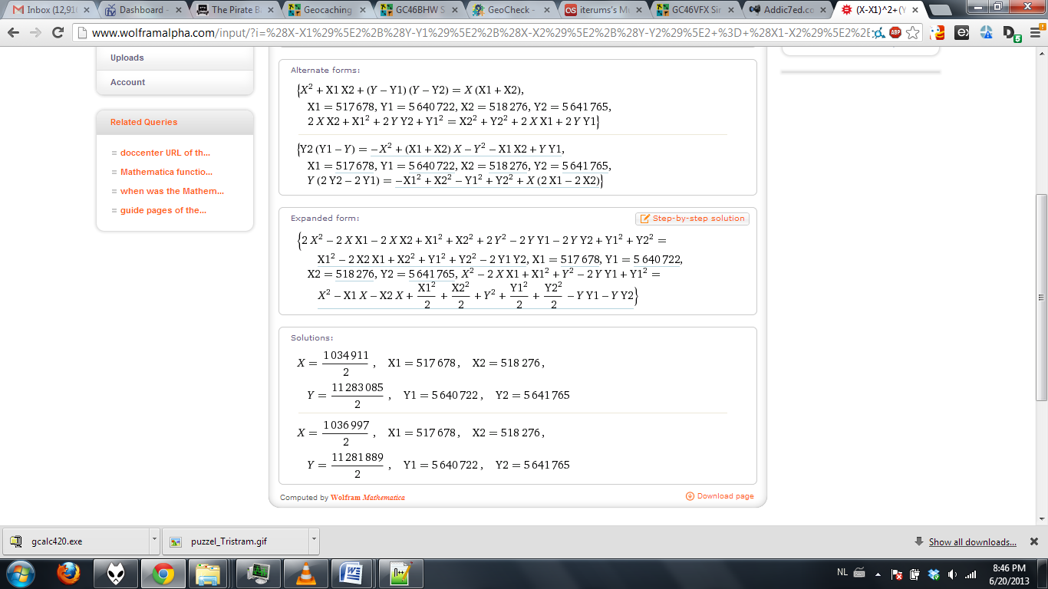

|  |  |
| --- | --- |
| **Congratulations - your solution is correct!!!** | |
| Cache Name: | |  | | --- | | [**Sir Galahad**](http://www.geocaching.com/seek/cache_details.aspx?wp=GC46BHW) | |
| GC Code: | **GC46BHW** |
| Your coordinates are within 10 meters of the correct coordinates! | |
| http://geocheck.org/md5pics/b8a19041488233b70f6f22edd9efaf11.jpg | |
| Proficiat, je hebt de schat gevonden, al dan niet bij benadering. De exacte locatie is N50°55.191 E003°15.791  Als bonus krijg je nog een hint voor Sir Gawain: "KAKURASU" | |